VOLUME 3
MOVEIT FOR ROBOT MOTION PLANNING
Motion Planning | Robot Modelling | MoveIt Setup Assistant | Motion Planning and Execution
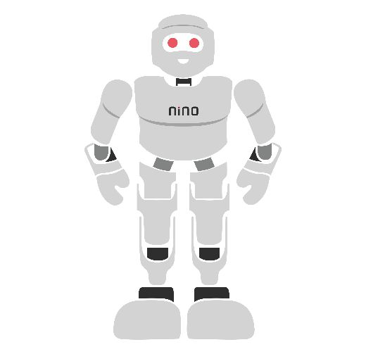

Module Overview
Telling a robot arm "put your gripper there" sounds simple, but the robot must answer several hard questions first: which joint angles reach that point, how to get there without hitting the table, itself or a person, and how fast each joint may move. Motion planning answers these questions, and MoveIt is the most widely used open-source software for doing it. MoveIt runs on ROS 2 and is used on thousands of research and industrial arms.
This module builds the skills step by step. Section 1 explains the ideas behind motion planning — configuration space, collision checking, sampling-based planners and trajectory timing. Section 2 shows how to model a robot for MoveIt (URDF, SRDF and configuration files). Section 3 uses the MoveIt Setup Assistant to turn that model into a ready-to-run MoveIt package. Section 4 covers planning and execution — from clicking in RViz to writing C++ programs that avoid obstacles and perform a pick-and-place sequence. All examples use one simple 6-joint arm, my_arm. The module builds on the ROS 2 module and uses ROS 2 Jazzy on Ubuntu 24.04. Taught end-to-end, it is designed to fill approximately 30–34 hours of instruction and practice.
# | Topic | Hands-on Focus
1 | Motion Planning Fundamentals | Lab 1: Build an RRT planner in Python
2 | Robot Modelling for MoveIt | Lab 2: Model my_arm (URDF)
3 | MoveIt Setup Assistant | Lab 2: Generate my_arm_moveit_config
4 | Motion Planning and Execution | Lab 3: Plan and execute in RViz and C++
5 | Practical Lab Exercises (with model solutions) | Labs 1–3
6 | Integrated Mini-Project: Pick and Place | Collision-aware motion sequence
7–8 | Troubleshooting, Assessment and Revision | Formula sheet, questions, rubric

Learning Outcomes
By the end of this module, learners will be able to:
- Explain configuration space, collision checking, paths and trajectories, and how sampling-based planners such as RRT work.
- Compare planner families (OMPL sampling-based, Pilz industrial, CHOMP/STOMP optimisation) and choose one for a task.
- Model a robot arm for MoveIt with URDF/xacro, an SRDF and the kinematics, joint-limit and controller configuration files.
- Use the MoveIt Setup Assistant to create, launch and correct a MoveIt configuration package.
- Plan and execute motions in RViz and in C++ with named, joint, pose and Cartesian goals, collision objects and attached objects.
- Diagnose common failures such as unreachable goals, collisions, missing limits and controller problems.
Hardware and Software Required
Item | Purpose | Notes
PC: 4-core CPU, 8 GB RAM (16 GB recommended) | Run ROS 2, MoveIt and RViz | Graphics acceleration helps RViz
Ubuntu 24.04 + ROS 2 Jazzy desktop | Base system (see ROS 2 module) | WSL2 or a virtual machine also works
MoveIt 2: sudo apt install ros-jazzy-moveit | Planning, Setup Assistant, RViz plugin | Free, open source
ros-jazzy-urdf-tutorial, ros-jazzy-xacro | View and check URDF models | Free
Python 3 with NumPy and Matplotlib (or Google Colab) | Lab 1 planner (no ROS needed) | Free
Optional: a real or Gazebo-simulated arm with ros2_control | Execute on hardware | Not required: labs use mock hardware

1. Motion Planning Fundamentals

1.1 What Is Motion Planning?
Motion planning finds a way to move a robot from a start to a goal while respecting constraints: no collisions, joint limits, speed limits and sometimes extra rules such as "keep the cup upright". The answer comes in two layers. A path is the geometric route — an ordered list of robot configurations. A trajectory adds timing — when the robot should be at each configuration, with velocities and accelerations. The planner finds the path; a time-parameterisation step turns it into a trajectory that the motor controllers can follow.

1.2 Configuration Space
A robot’s configuration is the list of all its joint values, q = (q₁, q₂, …, qₙ). The set of all possible configurations is the configuration space (C-space); its dimension equals the number of joints. Every point in C-space is one complete pose of the robot. Points where the robot touches an obstacle or itself form the C-obstacle region; the rest is free space. Planning a collision-free motion is then the same as drawing a line through free space from the start point to the goal point (Figure 1.1).
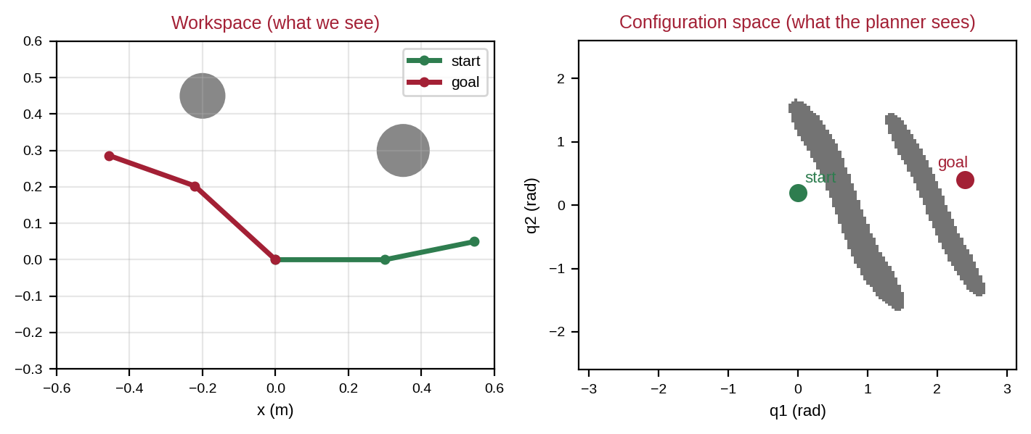
Figure 1.1: Two round obstacles in the workspace of a 2-link arm (left) become two long curved regions in its configuration space (right).
Simple obstacles in the workspace become complicated shapes in C-space, and C-space grows quickly with the number of joints. Worked example 1.1. Dividing each joint of a 6-joint arm into 1° steps gives 360⁶ ≈ 2.2 × 10¹⁵ grid cells — far too many to check one by one. This is why practical planners sample C-space instead of mapping all of it.

1.3 Collision Checking and the Planning Scene
The planner repeatedly asks: "is this configuration collision-free?" and "is the straight motion between these two configurations collision-free?". A collision checker (MoveIt uses the FCL library by default) answers by placing the robot’s collision shapes at the given joint values and testing them against each other and against the planning scene — the description of everything around the robot: tables, walls, boxes and objects already held by the gripper. Simple shapes (boxes, cylinders, spheres) are checked much faster than detailed meshes.

1.4 Sampling-Based Planners: RRT and Friends
The Rapidly-exploring Random Tree (RRT) grows a tree of collision-free configurations from the start (Figure 1.2). In each iteration it (1) picks a random configuration, (2) finds the nearest node already in the tree, (3) takes a small step towards the random sample and adds the new node if the step is collision-free. Because random samples are spread everywhere, the tree quickly spreads into unexplored areas. With a small goal bias (e.g. 10 % of samples are the goal itself) the tree is also pulled towards the goal.
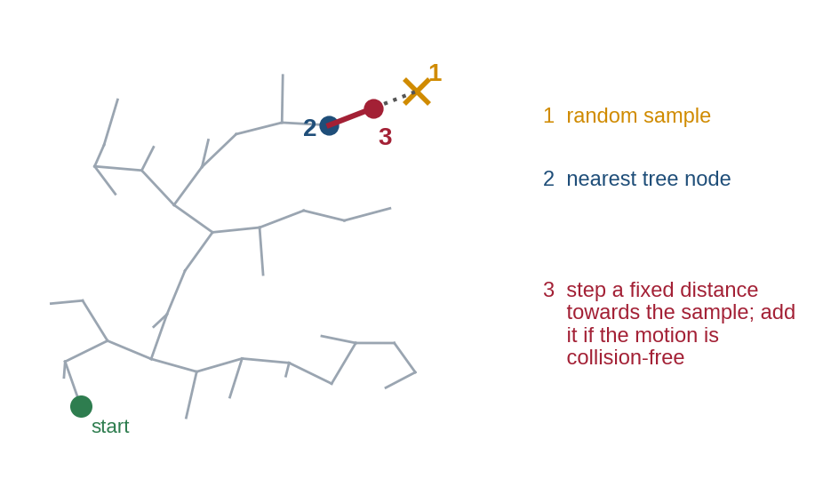
Figure 1.2: One RRT iteration: random sample, nearest tree node and a collision-checked step towards the sample.
Planner | Family | Idea in one line | Typical use
RRTConnect (MoveIt default) | Sampling (OMPL) | Two trees, from start and goal, grow towards each other | Fast general-purpose planning
RRT* / PRM* | Sampling, optimising | Keep improving the path while time remains | Shorter, smoother paths
PRM | Sampling (OMPL) | Build a reusable roadmap of free configurations | Many queries in one scene
CHOMP, STOMP | Optimisation | Start from a guess and push it away from obstacles | Smooth paths, refining others
Pilz PTP / LIN / CIRC | Industrial (analytic) | Joint-space move, straight line or arc | Predictable industrial motions

Sampling-based planners are probabilistically complete: if a path exists, the chance of finding it approaches 100 % as planning time increases, but each run may give a different, slightly wandering path. MoveIt therefore simplifies (shortcuts) paths after planning — in Lab 1 shortcutting reduces a 44-waypoint path to 5 waypoints.

1.5 Inverse Kinematics and Constraints
Users usually give goals as a pose of the tool (position and orientation), but planners work in joint space. Inverse kinematics (IK) converts the pose into joint values. A 6-joint arm usually has several IK solutions for one pose (elbow up or down, wrist flipped), or none if the pose is out of reach. Path constraints restrict how the robot moves on the way, for example keeping the tool level or inside a box; they make planning harder and slower.

1.6 From Path to Trajectory: Timing
Each joint has a maximum velocity v_max and acceleration a_max. A simple timing law is the trapezoidal velocity profile (Figure 1.3): accelerate at a_max, cruise at v_max, then brake. For a joint move Δq:
If Δq ≥ v_max² ÷ a_max: T = Δq ÷ v_max + v_max ÷ a_max; otherwise T = 2√(Δq ÷ a_max) (1.1)
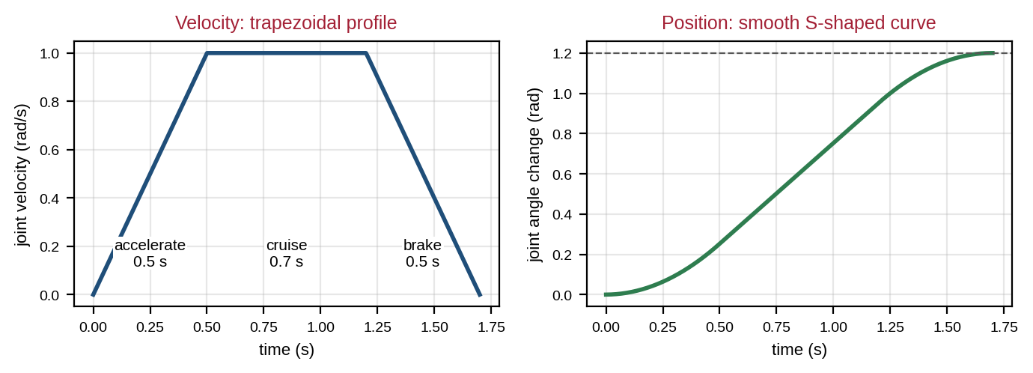
Figure 1.3: Trapezoidal velocity profile and resulting position curve for Δq = 1.2 rad, v_max = 1 rad/s, a_max = 2 rad/s².
Worked example 1.2. Δq = 1.2 rad, v_max = 1.0 rad/s, a_max = 2.0 rad/s². Since 1.2 ≥ 1²/2 = 0.5, T = 1.2 + 0.5 = 1.7 s (0.5 s accelerating, 0.7 s cruising, 0.5 s braking). With MoveIt’s velocity and acceleration scaling factors set to 0.5 (v = 0.5, a = 1.0): T = 2.4 + 0.5 = 2.9 s. A short move of 0.3 rad never reaches full speed: T = 2√(0.3/2) = 0.77 s. When several joints move together, the slowest joint sets the time and the others are slowed to finish together. MoveIt’s default time-optimal trajectory generation (TOTG) does this along the whole path.

1.7 What Is MoveIt?
MoveIt is an open-source motion-planning framework that combines all of the above: robot model loading, IK solvers, collision checking, several planner libraries, trajectory timing, execution through controllers, 3D perception of obstacles, and visual tools in RViz. It began in 2011 and has been used on hundreds of robot models. MoveIt 2 is the ROS 2 version and is maintained by PickNik Robotics with a large community. Its main parts are explained in Section 4.

1.8 Common Mistakes to Avoid
- Confusing a path (geometry) with a trajectory (geometry plus timing).
- Expecting the same path every time from a random sampling planner.
- Using very detailed meshes for collision checking, making planning slow.
- Giving pose goals that are outside the workspace or need impossible orientations.

2. Robot Modelling for MoveIt

2.1 What MoveIt Needs to Know
MoveIt needs two descriptions of the robot (Figure 2.1). The URDF describes the physical robot: links, joints, axes, joint limits and collision shapes (introduced in the ROS 2 module). The SRDF (Semantic Robot Description Format) adds information that only matters for planning: which joints form a planning group, which link is the end effector, useful named poses, how the robot is fixed to the world and which link pairs never need collision checks. A set of YAML files adds the IK solver, velocity and acceleration limits, and controllers.
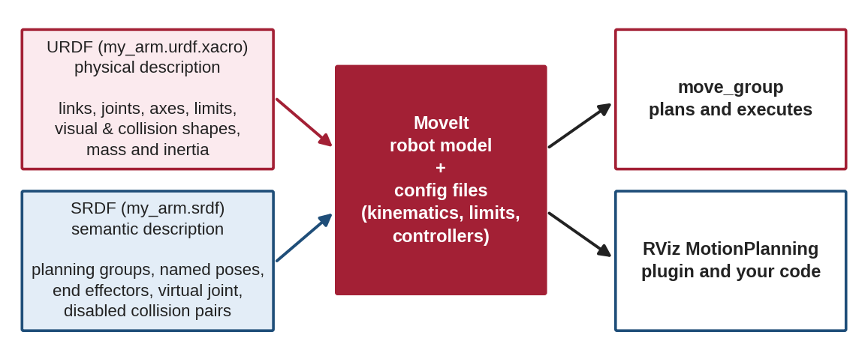
Figure 2.1: The URDF (physical) and SRDF (semantic) descriptions plus configuration files form MoveIt’s robot model.

2.2 The Example Robot: my_arm
my_arm is a simple 6-joint arm built from cylinders of radius 0.04 m (Figure 2.2). Joints 1, 4 and 6 rotate about their link’s long axis (z); joints 2, 3 and 5 bend the arm (about y). The last three joints form a compact spherical wrist, so the arm can reach a range of positions with any tool orientation. Its frame tool0 at the tip is the end-effector frame used in pose goals.
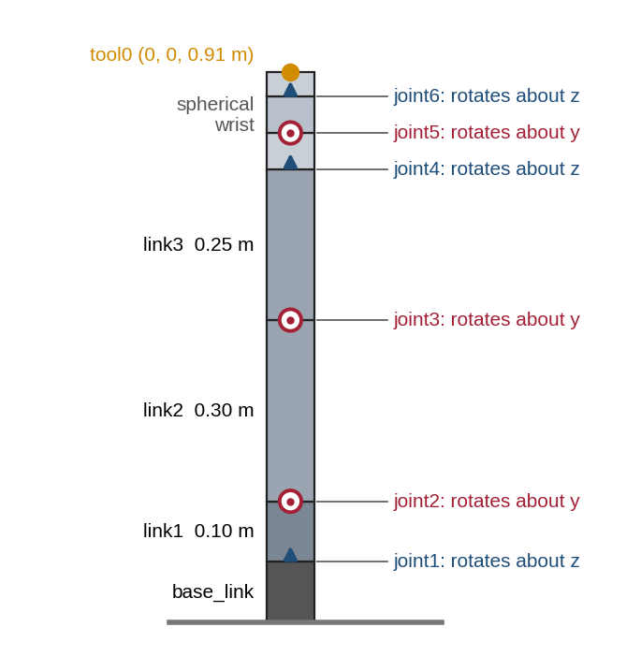
Figure 2.2: my_arm at its home pose (all joints at zero), showing links, joint axes and the tool0 frame.
Joint | Axis | Position above parent | Limits (rad) | Role
joint1 | z | 0.10 m (top of base) | −π … π | Turn the whole arm (shoulder pan)
joint2 | y | 0.10 m | −1.9 … 1.9 | Shoulder lift
joint3 | y | 0.30 m (end of link2) | −2.4 … 2.4 | Elbow
joint4 | z | 0.25 m (end of link3) | −π … π | Wrist roll
joint5 | y | 0.06 m | −2.0 … 2.0 | Wrist pitch
joint6 | z | 0.06 m | −π … π | Tool roll

Worked example 2.1. At the home pose every link is vertical, so tool0 sits at height 0.10 + 0.10 + 0.30 + 0.25 + 0.06 + 0.06 + 0.04 = 0.91 m. Joint 2 is 0.20 m above the base, so the maximum reach measured from joint 2 is 0.30 + 0.25 + 0.06 + 0.06 + 0.04 = 0.71 m: any target further than this from the shoulder has no IK solution. For the named pose ready (joint2 = 0.6, joint3 = 1.2, joint5 = 0.9 rad, others 0), forward kinematics gives tool0 at (0.514, 0, 0.287) m, pointing mostly downward — a good starting pose above a table.
The complete xacro file is listed in Lab 2. Two xacro macros keep it short: cyl_link creates a link with matching visual, collision and inertial parts, and rev_joint creates a revolute joint with limits. Inertia is computed inside the macro from the cylinder formula; for link2 (m = 1.2 kg, r = 0.04 m, length 0.30 m): Ixx = Iyy = 1.2 × (3 × 0.0016 + 0.09) ÷ 12 = 0.0095 kg·m² and Izz = 1.2 × 0.0016 ÷ 2 = 0.00096 kg·m².

2.3 Good Models for Planning
- Collision geometry: use simple primitives or simplified meshes slightly larger than the real part; keep detailed meshes for visuals only.
- Joint limits: use the real mechanical limits; MoveIt will never plan beyond them.
- Frames: follow REP 103 (x forward, z up, metres, radians) and give the tool a clearly named tip frame such as tool0.
- One tree: every link must be connected; MoveIt fixes the root to the world through the SRDF virtual joint.

2.4 The SRDF
The SRDF for my_arm, as generated by the Setup Assistant in Lab 2, defines one planning group arm as the chain from base_link to tool0, two named poses, a fixed virtual joint to the world, and the link pairs whose collisions are never checked:
<?xml version="1.0" encoding="UTF-8"?>
<!-- my_arm.srdf - semantic description (generated by the MoveIt Setup Assistant, then reviewed) -->
<robot name="my_arm">
<!-- planning group: the chain from the base to the tool frame -->
<group name="arm">
<chain base_link="base_link" tip_link="tool0"/>
</group>
<!-- named poses that can be used as goals -->
<group_state name="home" group="arm">
<joint name="joint1" value="0"/> <joint name="joint2" value="0"/> <joint name="joint3" value="0"/>
<joint name="joint4" value="0"/> <joint name="joint5" value="0"/> <joint name="joint6" value="0"/>
</group_state>
<group_state name="ready" group="arm">
<joint name="joint1" value="0"/> <joint name="joint2" value="0.6"/> <joint name="joint3" value="1.2"/>
<joint name="joint4" value="0"/> <joint name="joint5" value="0.9"/> <joint name="joint6" value="0"/>
</group_state>
<!-- fixes the robot base to the world -->
<virtual_joint name="virtual_joint" type="fixed" parent_frame="world" child_link="base_link"/>
<!-- link pairs that never need collision checking -->
<disable_collisions link1="base_link" link2="link1" reason="Adjacent"/>
<disable_collisions link1="base_link" link2="link2" reason="Never"/>
<disable_collisions link1="link1" link2="link2" reason="Adjacent"/>
<disable_collisions link1="link2" link2="link3" reason="Adjacent"/>
<disable_collisions link1="link3" link2="link4" reason="Adjacent"/>
<disable_collisions link1="link4" link2="link5" reason="Adjacent"/>
<disable_collisions link1="link5" link2="link6" reason="Adjacent"/>
</robot>

Disabling collision checks for pairs that are adjacent or can never touch speeds up every collision check. Worked example 2.2. my_arm has 7 links with geometry, giving 7 × 6 ÷ 2 = 21 link pairs. Disabling the 6 adjacent pairs and one pair that can never touch leaves 14 pairs to check for every configuration — one third fewer.

2.5 Configuration Files
kinematics.yaml selects the IK solver for each group. KDL is the default; alternatives such as TRAC-IK or pick_ik can be more robust. joint_limits.yaml gives velocity and acceleration limits used for timing; these can be lower than the URDF limits for safety:
# config/kinematics.yaml
arm:
kinematics_solver: kdl_kinematics_plugin/KDLKinematicsPlugin
kinematics_solver_search_resolution: 0.005
kinematics_solver_timeout: 0.005

# config/joint_limits.yaml (excerpt) - every joint needs acceleration limits for trajectory timing
joint_limits:
joint1:
has_velocity_limits: true
max_velocity: 1.5
has_acceleration_limits: true
max_acceleration: 3.0

2.6 ros2_control for Arms
MoveIt does not drive motors directly. It sends a planned trajectory to a controller through the FollowJointTrajectory action. In ROS 2 this controller is usually the joint_trajectory_controller from ros2_control, which runs on real hardware, in Gazebo, or on mock hardware (a software stand-in that simply copies commands to states — ideal for learning). The Setup Assistant adds the needed <ros2_control> tags and controller files automatically.

2.7 Common Mistakes to Avoid
- Missing or zero acceleration limits in joint_limits.yaml — trajectory timing fails.
- Planning group that does not include the end-effector link used in pose goals.
- Collision shapes much bigger than the real robot, making many goals "in collision".
- Disabling collision checks for pairs that can actually collide.

3. MoveIt Setup Assistant

3.1 What It Does
The MoveIt Setup Assistant (MSA) is a graphical tool that reads a URDF/xacro, guides you through the semantic choices of Section 2 and then generates a complete MoveIt configuration package — SRDF, YAML files, ros2_control files and launch files. Start it with:
sudo apt install ros-jazzy-moveit # once
ros2 launch moveit_setup_assistant setup_assistant.launch.py

3.2 The Steps
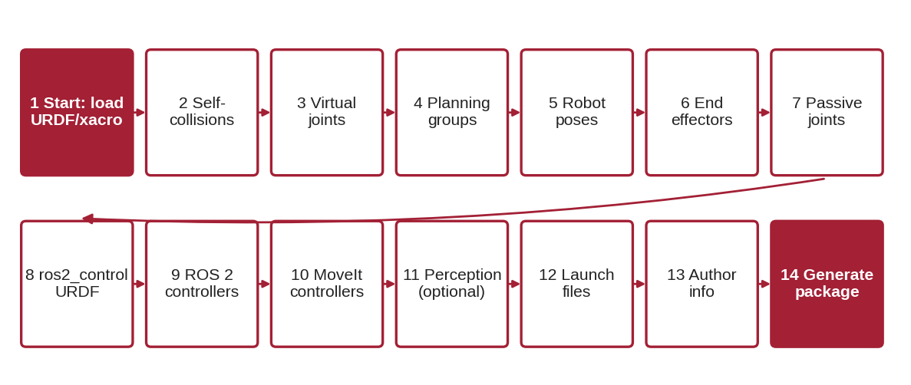
Figure 3.1: The MoveIt Setup Assistant steps, from loading the URDF to generating the package.
Step | What to do for my_arm | Why
Start | Create New MoveIt Configuration Package; browse to my_arm.urdf.xacro; Load Files | Reads the robot model
Self-Collisions | Keep the default sampling density; Generate Collision Matrix | Finds link pairs that never or always collide
Virtual Joints | Name virtual_joint, child base_link, parent world, type fixed | Fixes the arm base to the world
Planning Groups | Add group arm; kinematic solver KDL; Add Kin. Chain base_link → tool0 | Defines what MoveIt plans for
Robot Poses | Add home (all 0) and ready (0, 0.6, 1.2, 0, 0.9, 0) | Named goals for quick moves
End Effectors | Skip (no gripper group) or add one if a gripper exists | Links a gripper group to the arm
Passive Joints | None | For joints without motors
ros2_control URDF | Command interface: position; state interfaces: position, velocity | Adds ros2_control tags (mock hardware)
ROS 2 Controllers | Auto Add JointTrajectoryController for each planning group | Creates ros2_controllers.yaml
MoveIt Controllers | Auto Add FollowJointTrajectory controllers | Tells MoveIt which controller to use
Perception | None (optional 3D sensors) | Adds point-cloud obstacle input
Launch Files | Keep all selected | demo, move_group, RViz, etc.
Author Information | Your name and e-mail | Required for package.xml
Configuration Files | Folder ~/ros2_ws/src/my_arm_moveit_config; Generate Package | Writes all files

3.3 The Generated Package
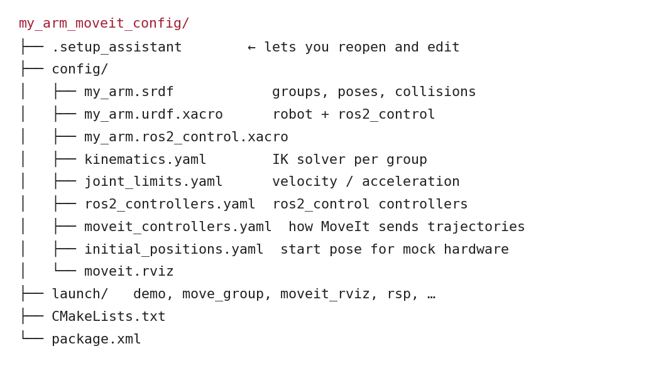
Figure 3.2: Structure of the generated my_arm_moveit_config package.
The hidden .setup_assistant file lets you reopen the package later with "Edit Existing MoveIt Configuration Package" — always change the configuration that way or by hand-editing the YAML files carefully, then rebuild.

3.4 Building and Running the Demo
# edit config/joint_limits.yaml: has_acceleration_limits: true, max_acceleration: 3.0 (all joints)
cd ~/ros2_ws && colcon build --symlink-install && source install/setup.bash
ros2 launch my_arm_moveit_config demo.launch.py

The demo launch file starts robot_state_publisher, ros2_control with mock hardware, the controllers, the move_group node and RViz with the MotionPlanning plugin. Drag the interactive marker at the tool, press Plan & Execute, and the arm moves. To try MoveIt before modelling your own robot, the ready-made Panda arm configuration can be installed and started the same way (package moveit_resources_panda_moveit_config, if available for your distribution).

3.5 Common Mistakes to Avoid
- Loading a xacro that needs arguments without providing them in the Start step.
- Generating the package outside the workspace src folder, so colcon never builds it.
- Skipping the controller steps — plans work, but Execute fails.
- Forgetting acceleration limits, which the generated joint_limits.yaml may leave at zero or disabled.

4. Motion Planning and Execution

4.1 The move_group Architecture
At the centre of MoveIt is the move_group node (Figure 4.1). It reads the URDF, SRDF and configuration, listens to /joint_states, keeps an up-to-date planning scene, runs planning pipelines, computes IK with a kinematics plugin and sends finished trajectories to controllers through its trajectory execution manager. Users talk to move_group through the RViz plugin, the C++ MoveGroupInterface or the Python MoveItPy API.
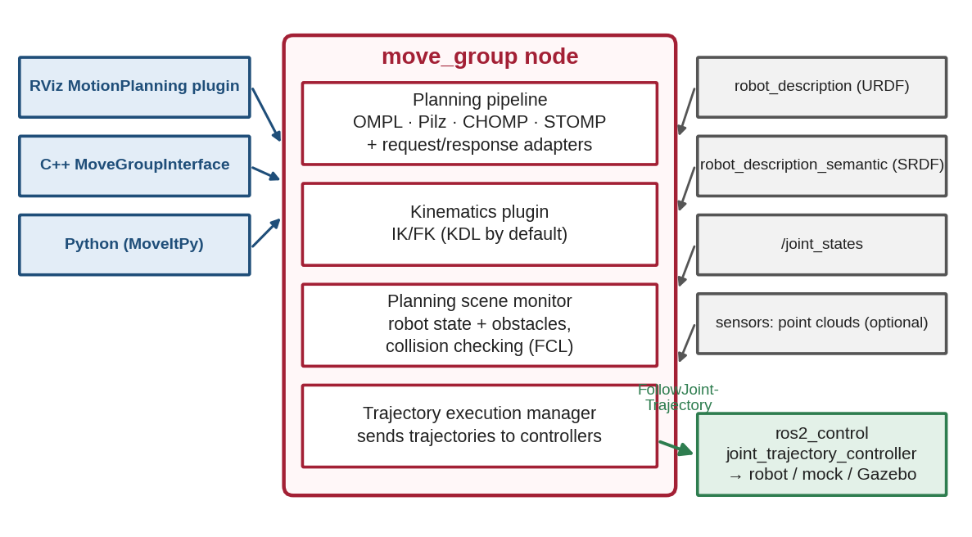
Figure 4.1: Architecture of the move_group node with its user interfaces, inputs and controller output.

4.2 The Planning Pipeline
Every request goes through a planning pipeline (Figure 4.2). Request adapters first fix small problems, such as a start state slightly outside the joint limits. The planner (by default OMPL with RRTConnect) finds a path. Response adapters then smooth and time-parameterise the path (TOTG), producing a trajectory of time-stamped positions and velocities ready for execution.
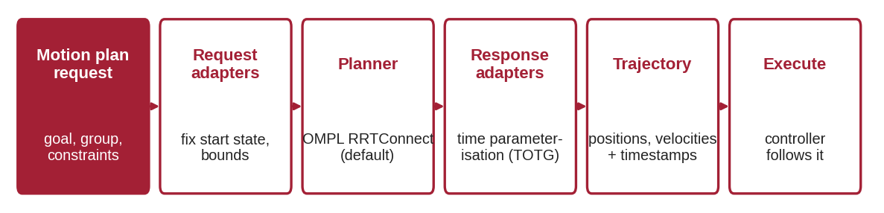
Figure 4.2: The MoveIt planning pipeline from request to executed trajectory.

4.3 Planning in RViz
The MotionPlanning panel in RViz is the quickest way to experiment. In the Planning tab choose the group, the planner (pipeline OMPL, RRTConnect), the planning time and the velocity and acceleration scaling factors. Set the goal by dragging the interactive marker, by choosing a named pose such as ready, or with random valid. Plan shows the motion as an animated preview; Execute sends it to the controller. The Scene Objects tab adds boxes, spheres or meshes to the planning scene so you can watch the planner go around them. The Joints tab sets a joint-space goal with sliders.

4.4 Programming with MoveGroupInterface
For applications, motion is commanded from code. The C++ MoveGroupInterface is the most widely used and best documented API:
Method | What it does
MoveGroupInterface arm(node, "arm") | Connect to move_group for planning group arm
setNamedTarget("ready") | Goal = a named pose from the SRDF
setJointValueTarget({q1 … q6}) | Goal in joint space (radians)
setPoseTarget(pose) | Goal pose of the end-effector link (IK is solved for you)
plan(plan) / execute(plan) | Plan a motion, then run it on the controller
computeCartesianPath(waypoints, 0.01, 0.0, traj) | Straight-line tool motion; returns the fraction achieved
setPlanningTime(s), setPlannerId(id) | Planning time limit and planner choice
setMaxVelocityScalingFactor(f) | Slow down (0 < f ≤ 1); same for acceleration
attachObject(id, link) / detachObject(id) | Carry a scene object with the tool

A MoveIt C++ node must be spun (for example in a background thread) so that it receives the robot’s current state. Orientation is given as a quaternion (x, y, z, w); for my_arm, (0, 1, 0, 0) means a rotation of 180° about y — the tool points straight down. The full programs are listed in Lab 3 and the mini-project.

4.5 The Planning Scene: Obstacles and Attached Objects
Obstacles are added as collision objects — shapes with an ID, a pose and a frame — through the PlanningSceneInterface or the RViz Scene Objects tab; 3D cameras can also add them automatically (an occupancy map, OctoMap). When the robot grasps an object, the object is attached to the tool link: from then on it moves with the robot, the planner avoids hitting anything with it, and collisions between the object and the gripper are allowed. After placing it, the object is detached and becomes part of the world again.

4.6 Cartesian Paths and Industrial Motions
Free-space planners do not guarantee a straight tool path. For approaching and leaving a part, a Cartesian path is used: MoveIt interpolates the tool pose in small steps (e.g. 1 cm) and solves IK at each step. The returned fraction (0 to 1) tells how much of the line is possible — anything below 1.0 means the line hits a joint limit, singularity or obstacle. The Pilz industrial motion planner offers the same idea as a planner: PTP (point-to-point in joint space), LIN (straight line) and CIRC (circular arc), with predictable, repeatable results.

4.7 Execution, Speed and Safety
Plans are executed by the trajectory execution manager, which monitors progress and stops if the controller reports an error or the motion takes much longer than expected. Use the velocity and acceleration scaling factors (0.1–0.3) for first tests on real hardware, keep an emergency stop within reach, and always preview a plan in RViz before executing it. Beyond this module, MoveIt Servo provides real-time jogging with a joystick, and the MoveIt Task Constructor chains many planning stages into full pick-and-place tasks.

4.8 Common Mistakes to Avoid
- Executing an old plan after the robot has moved, or a pose goal for a link outside the group.
- Accepting a Cartesian path with fraction < 1 and executing only part of the motion.

5. Practical Lab Exercises
Lab 1 needs only Python (it runs in Google Colab) and shows what happens inside a planner. Labs 2 and 3 need Ubuntu 24.04 with ROS 2 Jazzy and MoveIt 2. Every lab ends with a model solution. Lab 1 outputs were produced by running the program; ROS outputs are typical examples, and planning times and paths vary from run to run.
Lab | Title | Sections | Time
1 | Build an RRT motion planner in configuration space | 1 | 3 h
2 | Model my_arm and generate its MoveIt package | 2, 3 | 3.5 h
3 | Plan and execute in RViz and in C++ | 4 | 3.5 h

Lab Exercise 1: Build an RRT Motion Planner in Configuration Space
Estimated time | Prerequisites
3 hours | Section 1; Python functions and NumPy

Objective
To implement collision checking, an RRT planner, path shortcutting and trapezoidal timing for a 2-link planar arm, and to see the planning problem in configuration space.
Working Principle
free(q) checks joint limits and tests 24 points along the links against circular obstacles with a 2 cm safety margin. edge_free() checks a motion by testing configurations every 0.02 rad. rrt() grows the tree exactly as in Figure 1.2 with a 10 % goal bias. shortcut() repeatedly tries to join two random waypoints directly. duration() applies equation (1.1) per segment, using the joint with the largest move. A fixed random seed makes the result repeatable.
Procedure
- Run the program and record the printed results; save the plot.
- Identify in the C-space plot the two obstacle regions and explain why they are long curved bands.
- Change the random seed to 2, 3 and 4. Record the number of tree nodes and the shortcut path time for each.
- Change the step size from 0.15 to 0.05 rad. Record the effect on the number of nodes.
- Move the goal to (0.7, 0.0) and run again. Explain the result.
- Move the goal to (2.4, −2.5) (seed 1). Compare the number of nodes and the path time with the original goal, and explain the difference.
Program Code
# Lab 1: sampling-based motion planning (RRT) for a 2-link planar arm, in configuration space
import numpy as np
import matplotlib.pyplot as plt

L1, L2 = 0.30, 0.25 # link lengths (m)
OBSTACLES = [(0.35, 0.30, 0.07), (-0.20, 0.45, 0.06)] # circles (x, y, radius) in the workspace
LIMITS = np.array([[-np.pi, np.pi], [-2.6, 2.6]]) # joint limits (rad)
rng = np.random.default_rng(1) # fixed seed -> repeatable result

def links(q):
"""Points along both links for configuration q = (q1, q2)."""
e = np.array([L1*np.cos(q[0]), L1*np.sin(q[0])])
t = e + L2*np.array([np.cos(q[0]+q[1]), np.sin(q[0]+q[1])])
s = np.linspace(0, 1, 12)[:, None]
return np.vstack([s*e, e + s*(t - e)])

def free(q):
"""True if q is inside the joint limits and no link point touches an obstacle (+2 cm margin)."""
if np.any(q < LIMITS[:, 0]) or np.any(q > LIMITS[:, 1]):
return False
pts = links(q)
return all(np.min(np.hypot(pts[:, 0]-x, pts[:, 1]-y)) > r + 0.02 for x, y, r in OBSTACLES)

def edge_free(a, b, step=0.02):
n = max(2, int(np.linalg.norm(b - a)/step))
return all(free(a + (b - a)*k/n) for k in range(n + 1))

def rrt(start, goal, step=0.15, goal_bias=0.1, iters=5000):
nodes, parent = [start], [-1]
for _ in range(iters):
sample = goal if rng.random() < goal_bias else rng.uniform(LIMITS[:, 0], LIMITS[:, 1])
i = int(np.argmin([np.linalg.norm(n - sample) for n in nodes])) # nearest node
d = sample - nodes[i]
new = nodes[i] + d*min(1.0, step/np.linalg.norm(d)) # steer one step
if edge_free(nodes[i], new):
nodes.append(new); parent.append(i)
if np.linalg.norm(new - goal) < step and edge_free(new, goal):
nodes.append(goal); parent.append(len(nodes) - 2)
path, k = [], len(nodes) - 1
while k != -1:
path.append(nodes[k]); k = parent[k]
return path[::-1], nodes, parent
return None, nodes, parent

def shortcut(path, tries=200):
path = list(path)
for _ in range(tries):
if len(path) < 3: break
i, j = sorted(rng.choice(len(path), 2, replace=False))
if j - i > 1 and edge_free(path[i], path[j]):
path = path[:i+1] + path[j:]
return path

def duration(path, vmax=1.0, amax=2.0):
"""Trapezoidal timing per segment; the joint with the largest move sets the time."""
t = 0.0
for a, b in zip(path[:-1], path[1:]):
d = np.max(np.abs(b - a))
t += 2*np.sqrt(d/amax) if d < vmax**2/amax else d/vmax + vmax/amax
return t

start, goal = np.array([0.0, 0.2]), np.array([2.4, 0.4])
assert free(start) and free(goal), "start and goal must be collision-free"
path, nodes, parent = rrt(start, goal)
print(f"tree nodes: {len(nodes)}, path found: {path is not None}")
L_raw = sum(np.linalg.norm(b - a) for a, b in zip(path[:-1], path[1:]))
smooth = shortcut(path)
L_s = sum(np.linalg.norm(b - a) for a, b in zip(smooth[:-1], smooth[1:]))
print(f"raw path: {len(path)} waypoints, length {L_raw:.2f} rad, time {duration(path):.2f} s")
print(f"shortcut: {len(smooth)} waypoints, length {L_s:.2f} rad, time {duration(smooth):.2f} s")

# --- plots: configuration space (left) and workspace (right)
fig, (a1, a2) = plt.subplots(1, 2, figsize=(11, 4.6))
g1, g2 = np.linspace(*LIMITS[0], 160), np.linspace(*LIMITS[1], 160)
occ = np.array([[not free(np.array([x, y])) for x in g1] for y in g2])
a1.imshow(occ, origin="lower", extent=[*LIMITS[0], *LIMITS[1]], cmap="Greys", alpha=0.5, aspect="auto")
for k, p in enumerate(parent):
if p >= 0: a1.plot(*np.c_[nodes[p], nodes[k]], color="0.7", lw=0.5)
a1.plot(*np.array(path).T, "b-", lw=1.5, label="RRT path")
a1.plot(*np.array(smooth).T, "r-o", lw=2, ms=4, label="after shortcutting")
a1.set_xlabel("q1 (rad)"); a1.set_ylabel("q2 (rad)"); a1.set_title("Configuration space (grey = collision)"); a1.legend(fontsize=8)
for x, y, rr in OBSTACLES: a2.add_patch(plt.Circle((x, y), rr, color="0.5"))
for q in np.linspace(0, 1, 9):
k = q*(len(smooth) - 1); i = min(int(k), len(smooth) - 2)
qq = smooth[i] + (smooth[i+1] - smooth[i])*(k - i)
pts = links(qq); a2.plot([0, pts[11, 0], pts[-1, 0]], [0, pts[11, 1], pts[-1, 1]], "-o", color=plt.cm.viridis(q), lw=2, ms=3)
a2.set_aspect("equal"); a2.set_xlim(-0.6, 0.6); a2.set_ylim(-0.3, 0.6); a2.grid(alpha=0.3)
a2.set_title("Workspace: arm moving start -> goal"); a2.set_xlabel("x (m)"); a2.set_ylabel("y (m)")
plt.tight_layout(); plt.savefig("lab1_output.png", dpi=150); plt.show()

Expected Output
tree nodes: 311, path found: True
raw path: 44 waypoints, length 6.37 rad, time 22.35 s
shortcut: 5 waypoints, length 4.61 rad, time 6.17 s

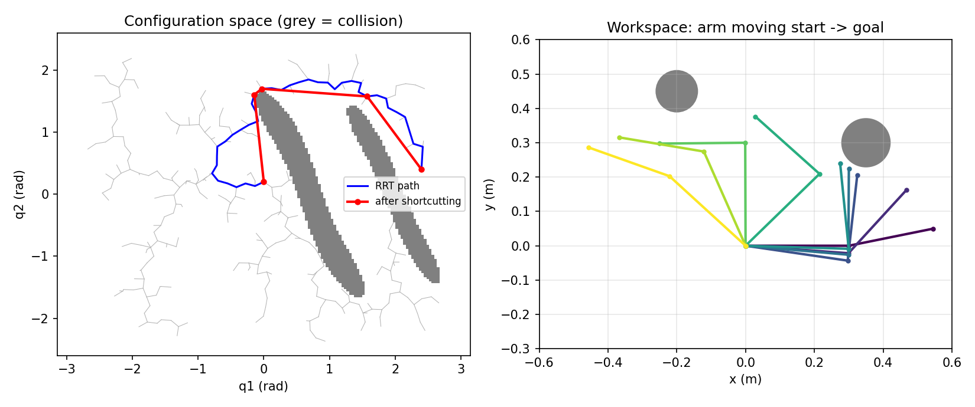
Figure 5.1: Output of Lab 1: RRT tree and paths in configuration space (left) and the arm moving around the obstacles (right).
Observation
# | What to observe | Your observation
1 | Printed results with seed 1
2 | Why obstacles form bands in C-space
3 | Nodes and path time for seeds 2, 3, 4
4 | Effect of step size 0.05 rad
5 | Result for goal (0.7, 0.0)
6 | Nodes and time for goal (2.4, −2.5)

Model Solution
# | Correct result | Explanation
1 | 311 nodes; 44 → 5 waypoints; 22.35 s → 6.17 s | Shortcutting removes the random wandering of RRT
2 | Each obstacle is hit by many (q1, q2) combinations | Link 2 can touch it for a range of q1 if q2 compensates
3 | Seed 2: 233 nodes, 6.18 s; seed 3: 617, 7.21 s; seed 4: 432, 6.43 s | RRT is random: effort and result vary, but a path is always found
4 | Seed 1: 737 nodes (2.4 times more) | Smaller steps explore more slowly but more finely
5 | AssertionError: start and goal must be collision-free | At (0.7, 0.0) the straight arm points straight into obstacle 1 — always check goals before planning
6 | 89 nodes, 3.95 s after shortcutting | This goal is reached with the elbow folded the other way, on the side away from the obstacles, so the tree finds it quickly

Conclusion
A complete sampling-based planner fits in about 100 lines; MoveIt adds 3D collision checking, many planners, IK and execution. Evidence: outputs, plot and table for the seed and step experiments.

Lab Exercise 2: Model my_arm and Generate Its MoveIt Package
Estimated time | Prerequisites
3.5 hours | Sections 2 and 3; ROS 2 module (packages, colcon, xacro)

Objective
To write and check the URDF/xacro of my_arm, generate my_arm_moveit_config with the Setup Assistant, fix its joint limits and plan the first motions in RViz.
Procedure
- Create a description package: cd ~/ros2_ws/src && ros2 pkg create --build-type ament_cmake --license Apache-2.0 my_arm_description && mkdir -p my_arm_description/urdf.
- Save the xacro below as my_arm_description/urdf/my_arm.urdf.xacro and add install(DIRECTORY urdf DESTINATION share/${PROJECT_NAME}) to its CMakeLists.txt. Build and source.
- Check it: xacro my_arm.urdf.xacro > /tmp/my_arm.urdf && check_urdf /tmp/my_arm.urdf; view it: ros2 launch urdf_tutorial display.launch.py model:=$(ros2 pkg prefix my_arm_description)/share/my_arm_description/urdf/my_arm.urdf.xacro and move the joint sliders.
- Run the Setup Assistant and complete every step as in Section 3.2; generate the package into ~/ros2_ws/src/my_arm_moveit_config.
- Open config/joint_limits.yaml; for every joint set has_acceleration_limits: true and max_acceleration: 3.0.
- Build, source and run ros2 launch my_arm_moveit_config demo.launch.py. Plan to the named poses and to a few random valid goals.
- Compare the SRDF the assistant generated with the one in Section 2.4.
Program Code
<?xml version="1.0"?>
<!-- my_arm: simple 6-DOF arm (spherical wrist) for MoveIt 2 labs -->
<robot name="my_arm" xmlns:xacro="http://www.ros.org/wiki/xacro">
<xacro:property name="r" value="0.04"/> <!-- link radius (m) -->

<!-- macro: cylinder link of length len along +z, with inertia -->
<xacro:macro name="cyl_link" params="name ln mass">
<link name="${name}">
<visual>
<origin xyz="0 0 ${ln/2}"/> <geometry><cylinder radius="${r}" length="${ln}"/></geometry>
</visual>
<collision>
<origin xyz="0 0 ${ln/2}"/> <geometry><cylinder radius="${r}" length="${ln}"/></geometry>
</collision>
<inertial>
<origin xyz="0 0 ${ln/2}"/> <mass value="${mass}"/>
<inertia ixx="${mass*(3*r*r+ln*ln)/12}" iyy="${mass*(3*r*r+ln*ln)/12}"
izz="${mass*r*r/2}" ixy="0" ixz="0" iyz="0"/>
</inertial>
</link>
</xacro:macro>

<!-- macro: revolute joint placed 'z' above the parent frame, rotating about 'axis' -->
<xacro:macro name="rev_joint" params="name parent child z axis lower upper">
<joint name="${name}" type="revolute">
<parent link="${parent}"/> <child link="${child}"/>
<origin xyz="0 0 ${z}"/> <axis xyz="${axis}"/>
<limit lower="${lower}" upper="${upper}" effort="50" velocity="1.5"/>
</joint>
</xacro:macro>

<xacro:cyl_link name="base_link" ln="0.10" mass="2.0"/>
<xacro:cyl_link name="link1" ln="0.10" mass="1.0"/>
<xacro:cyl_link name="link2" ln="0.30" mass="1.2"/>
<xacro:cyl_link name="link3" ln="0.25" mass="0.9"/>
<xacro:cyl_link name="link4" ln="0.06" mass="0.3"/>
<xacro:cyl_link name="link5" ln="0.06" mass="0.3"/>
<xacro:cyl_link name="link6" ln="0.04" mass="0.1"/>

<xacro:rev_joint name="joint1" parent="base_link" child="link1" z="0.10" axis="0 0 1" lower="${-pi}" upper="${pi}"/>
<xacro:rev_joint name="joint2" parent="link1" child="link2" z="0.10" axis="0 1 0" lower="-1.9" upper="1.9"/>
<xacro:rev_joint name="joint3" parent="link2" child="link3" z="0.30" axis="0 1 0" lower="-2.4" upper="2.4"/>
<xacro:rev_joint name="joint4" parent="link3" child="link4" z="0.25" axis="0 0 1" lower="${-pi}" upper="${pi}"/>
<xacro:rev_joint name="joint5" parent="link4" child="link5" z="0.06" axis="0 1 0" lower="-2.0" upper="2.0"/>
<xacro:rev_joint name="joint6" parent="link5" child="link6" z="0.06" axis="0 0 1" lower="${-pi}" upper="${pi}"/>

<!-- tool frame at the tip: this is the end-effector frame used for pose goals -->
<link name="tool0"/>
<joint name="tool0_joint" type="fixed">
<parent link="link6"/> <child link="tool0"/> <origin xyz="0 0 0.04"/>
</joint>
</robot>

Expected Output
$ check_urdf /tmp/my_arm.urdf
robot name is: my_arm
---------- Successfully Parsed XML ---------------
root Link: base_link has 1 child(ren)
child(1): link1
child(1): link2
child(1): link3
child(1): link4
child(1): link5
child(1): link6
child(1): tool0

In RViz the grey arm appears with an orange goal arm and a marker at the tool. Plan & Execute to ready moves the tool down to about (0.51, 0, 0.29) m.
Observation
# | What to observe | Your observation
1 | check_urdf result (root, number of links)
2 | Number of disabled collision pairs and their reasons
3 | What happens when planning before fixing joint_limits.yaml
4 | Tool position at the ready pose (RViz or ros2 run tf2_ros tf2_echo world tool0)

Model Solution
# | Correct result | Explanation
1 | Root base_link; 8 links (7 with geometry + tool0) | Verified with the xacro tool and a URDF parser
2 | At least the 6 adjacent pairs plus some "Never" pairs; exact count depends on sampling | Section 2.4; compare with the listed SRDF
3 | Planning may fail with an error about missing acceleration limits | Time parameterisation needs acceleration limits for every joint
4 | ≈ (0.514, 0.000, 0.287) m | Worked example 2.1 (forward kinematics)

Conclusion
A short xacro file plus the Setup Assistant gives a working MoveIt robot in under an hour. Evidence: check_urdf output, RViz screenshots, generated SRDF and edited joint_limits.yaml.

Lab Exercise 3: Plan and Execute in RViz and C++
Estimated time | Prerequisites
3.5 hours | Lab 2; Section 4

Objective
To compare planners in RViz, plan around obstacles, and write a C++ program that executes named, pose and joint goals.
Procedure
- With the demo running, plan from home to ready five times each with RRTConnect, RRTstar and the Pilz PTP planner (choose the pipeline and planner in the Planning tab). Record planning time and whether the path looks the same each time.
- In Scene Objects, add a 0.1 × 0.1 × 0.4 m box at (0.3, 0, 0.2). Plan from home to ready again and describe the motion.
- Create a C++ package: ros2 pkg create --build-type ament_cmake --license Apache-2.0 --dependencies rclcpp moveit_ros_planning_interface my_moveit_app. Save hello_moveit.cpp in src/ and add the CMake lines below.
- Build, source and run ros2 run my_moveit_app hello_moveit while the demo is running.
- Change the pose goal to (0.80, 0.0, 0.20) and run again. Record the result.
Program Code
// my_moveit_app/src/hello_moveit.cpp - plan and execute three kinds of goal with MoveGroupInterface
#include <memory>
#include <thread>
#include <rclcpp/rclcpp.hpp>
#include <moveit/move_group_interface/move_group_interface.h> // newer MoveIt: .hpp

using moveit::planning_interface::MoveGroupInterface;

// plan to the target that is currently set, then execute if planning succeeded
bool plan_and_execute(MoveGroupInterface & arm, const rclcpp::Logger & log, const char * step)
{
MoveGroupInterface::Plan plan;
bool ok = static_cast<bool>(arm.plan(plan));
if (!ok) {
RCLCPP_ERROR(log, "%s: planning failed", step);
return false;
}
arm.execute(plan);
RCLCPP_INFO(log, "%s: executed", step);
return true;
}

int main(int argc, char * argv[])
{
rclcpp::init(argc, argv);
auto node = std::make_shared<rclcpp::Node>(
"hello_moveit",
rclcpp::NodeOptions().automatically_declare_parameters_from_overrides(true));
auto log = node->get_logger();

// spin the node in the background so MoveGroupInterface can read the robot state
rclcpp::executors::SingleThreadedExecutor executor;
executor.add_node(node);
std::thread spinner([&executor]() { executor.spin(); });

MoveGroupInterface arm(node, "arm"); // planning group name from the SRDF
arm.setPlanningTime(5.0); // seconds the planner may use
arm.setMaxVelocityScalingFactor(0.5); // 50 % of the joint velocity limits
arm.setMaxAccelerationScalingFactor(0.5);

// 1. named goal (group_state in the SRDF)
arm.setNamedTarget("ready");
plan_and_execute(arm, log, "named goal 'ready'");

// 2. pose goal for tool0: 0.40 m forward, 0.10 m left, 0.30 m up, tool pointing down
geometry_msgs::msg::Pose target;
target.position.x = 0.40;
target.position.y = 0.10;
target.position.z = 0.30;
target.orientation.x = 0.0; // quaternion for 180 deg about y
target.orientation.y = 1.0;
target.orientation.z = 0.0;
target.orientation.w = 0.0;
arm.setPoseTarget(target);
plan_and_execute(arm, log, "pose goal");

// 3. joint-space goal (radians, joint1..joint6)
std::vector<double> joints = {0.0, 0.0, 0.0, 0.0, 0.0, 0.0};
arm.setJointValueTarget(joints);
plan_and_execute(arm, log, "joint goal 'home'");

rclcpp::shutdown();
spinner.join();
return 0;
}

# my_moveit_app/CMakeLists.txt - after find_package(...) lines
add_executable(hello_moveit src/hello_moveit.cpp)
ament_target_dependencies(hello_moveit rclcpp moveit_ros_planning_interface)
add_executable(pick_place_demo src/pick_place_demo.cpp)
ament_target_dependencies(pick_place_demo rclcpp moveit_ros_planning_interface)
install(TARGETS hello_moveit pick_place_demo DESTINATION lib/${PROJECT_NAME})

Expected Output
[INFO] [hello_moveit]: named goal 'ready': executed
[INFO] [hello_moveit]: pose goal: executed
[INFO] [hello_moveit]: joint goal 'home': executed

The arm moves to ready, then to the tool-down pose at (0.40, 0.10, 0.30) m, then back home. With the unreachable target, move_group reports that no IK solution was found and the program prints "pose goal: planning failed".
Observation
# | What to observe | Your observation
1 | Planning times and path repeatability: RRTConnect, RRTstar, Pilz PTP
2 | Motion with the box in the scene
3 | Terminal output of hello_moveit
4 | Result for the pose goal (0.80, 0.0, 0.20)

Model Solution
# | Correct result | Explanation
1 | RRTConnect: fastest, path varies; RRTstar: uses the full planning time, shorter paths; Pilz PTP: same motion every time | Sampling vs optimising vs analytic planners
2 | The arm bends around or over the box | The box is in the planning scene
3 | Three "executed" lines | All goals are reachable (an IK solution for the pose goal was confirmed numerically, e.g. q ≈ (0.25, 0.38, 1.44, 0, 1.32, 0.25) rad)
4 | Planning fails (no IK solution) | The target is 0.80 m from the shoulder; the maximum reach is 0.71 m

Conclusion
The same planning engine is used from RViz and from code; choosing goals and planners well matters as much as the code itself. Evidence: planner comparison table, screenshots and program output.

6. Integrated Mini-Project: Collision-Aware Pick and Place

6.1 Problem Statement
Program my_arm to move a small part from one position on a table to another without hitting the table or a post standing between the two positions (Figure 6.1). The sequence must use free-space planning between positions, straight-line Cartesian approach and retreat moves, and attach/detach the part so that MoveIt plans correctly while it is carried. A real gripper is not needed: attaching the object stands in for grasping.
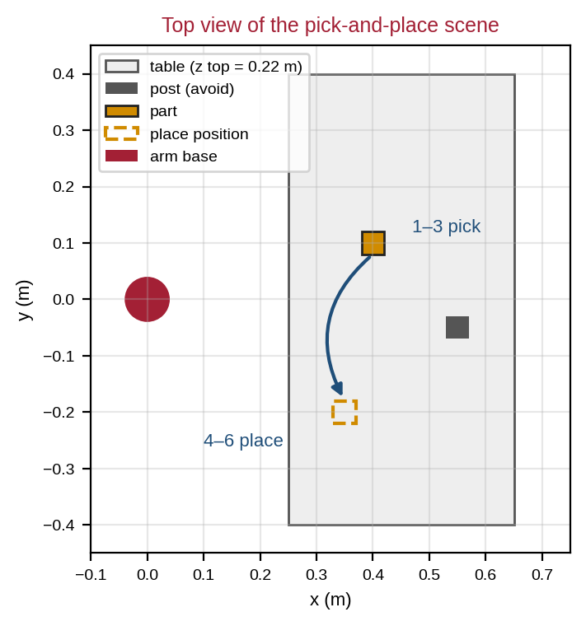
Figure 6.1: Top view of the pick-and-place scene used in the mini-project.

6.2 Design and Workflow
Step | Motion | Method
1 | Move above the part: tool at (0.40, 0.10, 0.40) m, pointing down | Pose goal, OMPL
2 | Approach 10 cm straight down | Cartesian path
3 | Attach the part, lift 10 cm | attachObject + Cartesian path
4 | Move above the place position (0.35, −0.20, 0.35) m around the post | Pose goal, OMPL
5 | Lower 10 cm, detach the part | Cartesian path + detachObject
6 | Retreat 10 cm, then return home | Cartesian path + named goal

All four tool poses were checked in advance with a numerical IK solver on the my_arm model: each has an exact solution, so planning failures in this project point to collisions, limits or configuration errors rather than to unreachable targets.

6.3 Code
Add pick_place_demo.cpp to the package from Lab 3 (the CMake lines are already in place), build, and run it while the demo launch file is running: ros2 run my_moveit_app pick_place_demo.
// my_moveit_app/src/pick_place_demo.cpp - collision-aware pick-and-place motion sequence
#include <memory>
#include <string>
#include <thread>
#include <vector>
#include <rclcpp/rclcpp.hpp>
#include <moveit/move_group_interface/move_group_interface.h> // newer MoveIt: .hpp
#include <moveit/planning_scene_interface/planning_scene_interface.h> // newer MoveIt: .hpp
#include <moveit_msgs/msg/collision_object.hpp>
#include <shape_msgs/msg/solid_primitive.hpp>

using moveit::planning_interface::MoveGroupInterface;
using moveit::planning_interface::PlanningSceneInterface;

// a box-shaped collision object of size (sx, sy, sz) centred at (x, y, z)
moveit_msgs::msg::CollisionObject make_box(const std::string & id, const std::string & frame,
double sx, double sy, double sz, double x, double y, double z)
{
moveit_msgs::msg::CollisionObject obj;
obj.header.frame_id = frame;
obj.id = id;
shape_msgs::msg::SolidPrimitive box;
box.type = shape_msgs::msg::SolidPrimitive::BOX;
box.dimensions = {sx, sy, sz};
geometry_msgs::msg::Pose pose;
pose.orientation.w = 1.0;
pose.position.x = x;
pose.position.y = y;
pose.position.z = z;
obj.primitives.push_back(box);
obj.primitive_poses.push_back(pose);
obj.operation = moveit_msgs::msg::CollisionObject::ADD;
return obj;
}

// tool0 pose at (x, y, z) pointing straight down
geometry_msgs::msg::Pose down_pose(double x, double y, double z)
{
geometry_msgs::msg::Pose p;
p.position.x = x;
p.position.y = y;
p.position.z = z;
p.orientation.y = 1.0; // (x, y, z, w) = (0, 1, 0, 0): 180 deg about y
p.orientation.w = 0.0;
return p;
}

bool move_to(MoveGroupInterface & arm, const geometry_msgs::msg::Pose & goal,
const rclcpp::Logger & log, const char * step)
{
arm.setPoseTarget(goal);
MoveGroupInterface::Plan plan;
if (!static_cast<bool>(arm.plan(plan))) {
RCLCPP_ERROR(log, "%s: planning failed", step);
return false;
}
arm.execute(plan);
RCLCPP_INFO(log, "%s: done", step);
return true;
}

// straight-line (Cartesian) move of the tool by dz metres
bool move_vertical(MoveGroupInterface & arm, const geometry_msgs::msg::Pose & from, double dz,
const rclcpp::Logger & log, const char * step)
{
geometry_msgs::msg::Pose to = from;
to.position.z += dz;
std::vector<geometry_msgs::msg::Pose> waypoints = {to};
moveit_msgs::msg::RobotTrajectory trajectory;
double fraction = arm.computeCartesianPath(waypoints, 0.01, 0.0, trajectory); // 1 cm steps
if (fraction < 0.95) {
RCLCPP_ERROR(log, "%s: only %.0f %% of the straight line is possible", step, fraction * 100.0);
return false;
}
arm.execute(trajectory);
RCLCPP_INFO(log, "%s: done", step);
return true;
}

int main(int argc, char * argv[])
{
rclcpp::init(argc, argv);
auto node = std::make_shared<rclcpp::Node>(
"pick_place_demo",
rclcpp::NodeOptions().automatically_declare_parameters_from_overrides(true));
auto log = node->get_logger();
rclcpp::executors::SingleThreadedExecutor executor;
executor.add_node(node);
std::thread spinner([&executor]() { executor.spin(); });

MoveGroupInterface arm(node, "arm");
arm.setMaxVelocityScalingFactor(0.3);
arm.setMaxAccelerationScalingFactor(0.3);
const std::string frame = arm.getPlanningFrame();

// build the scene: table, a post to avoid, and the part to move
PlanningSceneInterface scene;
scene.applyCollisionObjects({
make_box("table", frame, 0.40, 0.80, 0.02, 0.45, 0.00, 0.21),
make_box("post", frame, 0.04, 0.04, 0.20, 0.55, -0.05, 0.32),
make_box("part", frame, 0.04, 0.04, 0.04, 0.40, 0.10, 0.24)});

bool ok = true;
const auto pre_pick = down_pose(0.40, 0.10, 0.40);
const auto pre_place = down_pose(0.35, -0.20, 0.35);
ok = ok && move_to(arm, pre_pick, log, "1 move above part");
ok = ok && move_vertical(arm, pre_pick, -0.10, log, "2 approach part");
if (ok) {
arm.attachObject("part", arm.getEndEffectorLink()); // part now moves with the tool
}
ok = ok && move_vertical(arm, down_pose(0.40, 0.10, 0.30), 0.10, log, "3 lift part");
ok = ok && move_to(arm, pre_place, log, "4 move above place position");
ok = ok && move_vertical(arm, pre_place, -0.10, log, "5 lower part");
if (ok) {
arm.detachObject("part"); // part stays at the place position
}
ok = ok && move_vertical(arm, down_pose(0.35, -0.20, 0.25), 0.10, log, "6 retreat");
arm.setNamedTarget("home");
MoveGroupInterface::Plan home_plan;
if (static_cast<bool>(arm.plan(home_plan))) {
arm.execute(home_plan);
}
RCLCPP_INFO(log, "sequence %s", ok ? "completed" : "stopped early");

rclcpp::shutdown();
spinner.join();
return 0;
}

6.4 Test Cases, Limitations and Extensions
Test | Action | Expected result
TC1 | Run the program | Six steps report "done"; the part is shown at the place position
TC2 | Watch the part in RViz during steps 3–5 | It moves with the tool (attached colour)
TC3 | Move the post to (0.40, −0.05, 0.32) | Step 4 plans a different route around it
TC4 | Set pre_pick height to 0.30 m (approach would end at 0.20 m, inside the table) | The Cartesian approach reports < 95 % and the sequence stops early
TC5 | Velocity scaling 0.1 | Same motions, about three times slower

Limitations: no real gripper or force sensing; the part position is fixed in the code rather than detected by a camera; failures stop the sequence instead of re-trying. Extensions: add a gripper planning group and open/close commands; use the Pilz LIN planner for steps 2, 3, 5 and 6; read the part position from a topic; or rebuild the sequence with the MoveIt Task Constructor.

7. Troubleshooting and Common Mistakes
Problem | Likely cause | Fix
"Unable to sample any valid states for goal tree" | Goal in collision or no IK solution | Check reach and orientation; enable approximate IK in RViz to test
Planning fails only after adding objects | Object overlaps the robot or start state | Move the object; check the start state is collision-free
Error about acceleration limits | Missing limits in joint_limits.yaml | Set has_acceleration_limits: true and a max_acceleration
Plan works but Execute fails | Controllers not running or names differ | ros2 control list_controllers; check moveit_controllers.yaml
C++ node: "Failed to fetch current robot state" | Node not spun | Spin the node in a background thread
Cartesian path fraction < 1 | Joint limit, singularity or collision on the line | Shorter line, different start pose, or plan in free space
Robot moves too fast or jerks | Scaling factors at 1.0 | Use 0.1–0.5 scaling; check joint limits
Setup Assistant cannot load the model | xacro error or missing package path | Run xacro in a terminal first; source the workspace

8. Assessment and Revision

8.1 Formula and Command Sheet
Item | Formula / command
Configuration | q = (q₁ … qₙ); C-space dimension = number of joints
Trapezoidal timing | Δq ≥ v²/a: T = Δq/v + v/a; otherwise T = 2√(Δq/a)
Collision pairs | n links → n(n − 1)/2 pairs (minus disabled pairs)
Cylinder inertia | Ixx = Iyy = m(3r² + L²)/12; Izz = m r²/2
Setup Assistant | ros2 launch moveit_setup_assistant setup_assistant.launch.py
Demo | ros2 launch <robot>_moveit_config demo.launch.py
Tool-down quaternion (x, y, z, w) | (0, 1, 0, 0) = 180° about y

8.2 Short Conceptual Questions
- What is the difference between a path and a trajectory?
- Why do planners work in configuration space instead of the workspace?
- Explain the three steps of one RRT iteration.
- Why might the same planning request give different paths each time?
- What information is in the SRDF but not in the URDF?
- Why should collision checking be disabled for some link pairs, and which ones?
- What is the role of ros2_control in executing a MoveIt plan?
- When should a Cartesian path be used instead of free-space planning?
Answer key (brief): 1 — geometry vs geometry + timing. 2 — the robot becomes a single point; collision becomes a region. 3 — random sample, nearest node, collision-checked step. 4 — sampling planners use random numbers. 5 — groups, named poses, end effectors, virtual joint, disabled collisions. 6 — speed; adjacent or never-touching pairs. 7 — its controller follows the trajectory on hardware or mock. 8 — when the tool must move in a straight line (approach, insert, retreat).

8.3 Numerical Problems with Worked Solutions
Problem 1. A 7-joint arm, each joint divided into 2° steps. How many C-space cells? Solution: 180⁷ ≈ 6.1 × 10¹⁵ cells.
Problem 2. Joint move 2.0 rad, v_max = 1.5 rad/s, a_max = 3 rad/s². Time? Solution: v²/a = 0.75 ≤ 2.0, so T = 2.0/1.5 + 1.5/3 = 1.33 + 0.5 = 1.83 s.
Problem 3. Same joint, scaling 0.2 for velocity and acceleration. Solution: v = 0.3, a = 0.6; v²/a = 0.15 ≤ 2.0; T = 6.67 + 0.5 = 7.17 s.
Problem 4. Move of 0.2 rad with v_max = 1.5, a_max = 3. Solution: 0.2 < 0.75, triangular: T = 2√(0.2/3) = 0.52 s.
Problem 5. A robot has 9 links with geometry; 8 pairs are adjacent and 6 more never touch. How many pairs are checked? Solution: 9 × 8 ÷ 2 = 36; 36 − 14 = 22 pairs.
Problem 6. Is (0.5, 0.3, 0.6) m reachable by my_arm, whose shoulder is at (0, 0, 0.2) m and reach 0.71 m? Solution: distance = √(0.25 + 0.09 + 0.16) = 0.707 m — just inside the 0.71 m limit, reachable only with the arm almost straight (near a singular pose): avoid such targets.

8.4 Practical Checklist and Rubric
# | The learner can… | Done
1 | Explain and run an RRT planner and interpret C-space plots (Lab 1) | ☐
2 | Write and check a URDF/xacro arm model (Lab 2) | ☐
3 | Generate, fix and launch a MoveIt configuration package (Lab 2) | ☐
4 | Compare planners and plan around obstacles in RViz (Lab 3) | ☐
5 | Write C++ code with named, pose, joint and Cartesian goals (Lab 3, mini-project) | ☐

Criterion (4 marks each) | Excellent (4) | Good (3–2) | Needs work (1–0)
Planning concepts | Clear, correct, with examples | Minor gaps | Confuses key ideas
Robot modelling | Valid model, sensible limits and collisions | One error | Invalid model
Setup Assistant package | Runs; limits and controllers fixed | Runs with issues | Does not run
Planning and execution code | All goal types working, failures handled | Partly working | Not working
Mini-project and report | All tests pass; evidence complete | Some gaps | Not completed

Glossary
Term | Meaning in simple words
Attached object | Scene object that moves with a robot link while it is carried.
C-obstacle | Region of configuration space where the robot is in collision.
Cartesian path | Tool motion along a straight line or set of poses, computed step by step.
Collision object | Shape added to the planning scene as an obstacle.
Configuration (q) | List of all joint values of a robot.
Configuration space (C-space) | Space of all possible configurations.
End effector | The tool or gripper at the end of the arm.
FCL | Flexible Collision Library used by MoveIt for collision checking.
Goal bias | Fraction of RRT samples that are set to the goal.
IK (inverse kinematics) | Finding joint values for a desired tool pose.
Joint trajectory controller | ros2_control controller that follows timed joint trajectories.
KDL | Kinematics and Dynamics Library; MoveIt’s default IK solver plugin.
Mock hardware | Software stand-in that copies commands to states for testing.
MoveGroupInterface | C++ API for planning and executing with move_group.
move_group | Central MoveIt node that plans and executes motions.
MoveIt Setup Assistant | Tool that generates a MoveIt configuration package.
Named pose | Joint configuration stored in the SRDF under a name.
OMPL | Open Motion Planning Library of sampling-based planners.
Path | Sequence of configurations without timing.
Pilz planner | Industrial planner with PTP, LIN and CIRC motions.
Planning group | Set of joints MoveIt plans for (e.g. arm).
Planning scene | MoveIt’s model of the robot state and its surroundings.
Probabilistic completeness | Chance of finding a path tends to 100 % with more time.
RRT / RRTConnect | Random tree planners; RRTConnect grows two trees.
Shortcutting | Removing unnecessary waypoints from a path.
Singularity | Pose where the arm loses the ability to move in some direction.
SRDF | Semantic robot description: groups, poses, collisions.
Time parameterisation | Adding timing to a path to make a trajectory.
TOTG | Time-optimal trajectory generation, MoveIt’s default timing method.
Trajectory | Path with time stamps, velocities and accelerations.
Velocity scaling factor | Fraction (0–1) of maximum joint speed used for a motion.
Virtual joint | SRDF joint that connects the robot root to the world.

References
The papers describe the algorithms used inside MoveIt; the online documentation is the authoritative and most up-to-date source for commands, file formats and APIs, which change between MoveIt releases.
[1] Coleman, D., Sucan, I., Chitta, S., & Correll, N. (2014). Reducing the barrier to entry of complex robotic software: a MoveIt! case study. Journal of Software Engineering for Robotics, 5(1), 3–16.
[2] Sucan, I. A., Moll, M., & Kavraki, L. E. (2012). The Open Motion Planning Library. IEEE Robotics & Automation Magazine, 19(4), 72–82.
[3] LaValle, S. M. (2006). Planning Algorithms. Cambridge University Press. Free online: http://planning.cs.uiuc.edu/
[4] LaValle, S. M. (1998). Rapidly-exploring random trees: A new tool for path planning. Technical Report TR 98-11, Iowa State University.
[5] Kuffner, J. J., & LaValle, S. M. (2000). RRT-Connect: An efficient approach to single-query path planning. Proc. IEEE ICRA.
[6] Kavraki, L. E., Švestka, P., Latombe, J.-C., & Overmars, M. H. (1996). Probabilistic roadmaps for path planning in high-dimensional configuration spaces. IEEE Transactions on Robotics and Automation, 12(4), 566–580.
[7] Karaman, S., & Frazzoli, E. (2011). Sampling-based algorithms for optimal motion planning. International Journal of Robotics Research, 30(7), 846–894.
[8] Ratliff, N., Zucker, M., Bagnell, J. A., & Srinivasa, S. (2009). CHOMP: Gradient optimization techniques for efficient motion planning. Proc. IEEE ICRA.
[9] Kalakrishnan, M., Chitta, S., Theodorou, E., Pastor, P., & Schaal, S. (2011). STOMP: Stochastic trajectory optimization for motion planning. Proc. IEEE ICRA.
[10] Kunz, T., & Stilman, M. (2012). Time-optimal trajectory generation for path following with bounded acceleration and velocity. Robotics: Science and Systems.
[11] Pan, J., Chitta, S., & Manocha, D. (2012). FCL: A general purpose library for collision and proximity queries. Proc. IEEE ICRA.
[12] Lynch, K. M., & Park, F. C. (2017). Modern Robotics: Mechanics, Planning, and Control. Cambridge University Press.
[13] MoveIt 2 documentation and tutorials. https://moveit.picknik.ai/
[14] MoveIt project website. https://moveit.ai/
[15] ros2_control documentation. https://control.ros.org/

